



Sentry Intrinsically Safe Card Reader

User Manual

Contents

Page
Introduction 3
Certification Standard 3

Installation 4
Weatherproofing 6
Cable Entry 6
Cables 6
Hazardous Area Connections 6
Safe Area Connections 7

Operation 8
Sentry Models 8
Set Up & Configuration 9
Setting The Card Media Type 10
Configuring The Sentry Card Reader 10
Example Configuration String 12
Telemetry Block Structure 12
Escape Sequences 13
Card Media Specifications 14

System Options 15
Option1 – IS Sentry in Stand-alone mode 15

Option 2 – IS Sentry in multi-drop mode 15

Option 3 – IS Sentry connection to Mercury 17
Operator Interface

Option 4 – Safe Area Sentry Connections 17

Hazardous Area I/O Options – Sentry Expansion 18
Connections

Appendix A – Certificates of Conformity 19

Appendix B – Wiring Drawings 20

Appendix C – Ordering Details 21

Appendix D – More Information 22

Introduction

The Sentry card reader is an intrinsically safe card reader designed to read a variety of different card types in hazardous areas.

The intrinsic safety certification covers the joint arrangement of the electronics box and the different card reader heads that can be used.

A safe area version of the Sentry is also available.

Certification
Standard
Copies of SIRA certification No. 99ATEX2138X are included in Appendix A, showing EEx ia IIB T4, which is made up as follows:-

EEx = European certificate for Hazardous Areas.

ia = Intrinsically Safe for Zone 0, continuous
Hazardous vapours.

IIB = The gas groups, i.e. safe for all gases except
Hydrogen and Acetylene.

T4 = Component surface temperature cannot exceed
130°C, i.e. safe for all gasses except carbon
disulphide.

The “Conditions of Certification” show the maximum parameters of each of the input/output terminal blocks.

Installation

The Sentry card reader is approved for use in hazardous areas when used with the R007 barrier & communications interface or a direct equivalent.

The Intrinsically Safe Interface Module provides mutual galvanic isolation between 24V d.c. power, the I.S. hazard area connection and the host communication ports. These connections to the Mercury 2e Sentry Terminal allow a cable length of up to 1 kilometre. The communication ports provide for RS232 and differential transmit and receive terminals for RS422/485, with tri-state control.

The Sentry should be ordered as a complete unit comprising electronics box and appropriate reader head as required. The Sentry can then be mounted on any convenient flat surface using the four holes provided.

The dimensions of the box (excluding the card reader head) are shown in the diagram below.

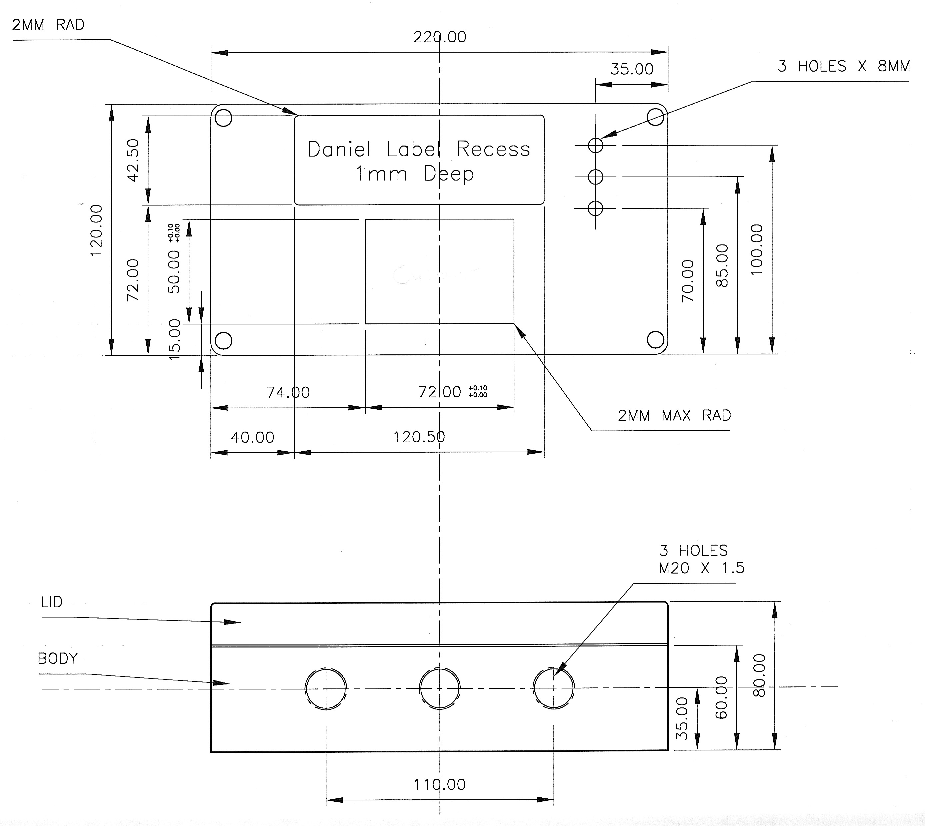

For hazardous area use, the Sentry must be connected to the R007 barrier & communications interface. The R007 must be located in the safe area.

A drawing of the interface module, which can be mounted either on a DIN rail or suitable flat surface, is shown below.

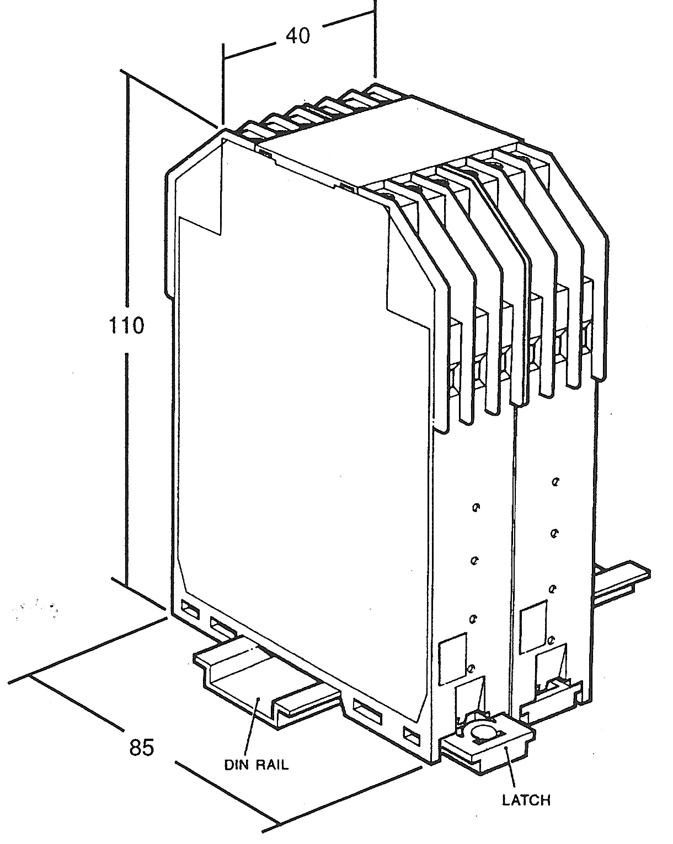

Weatherproofing

The Sentry electronics box and card reader head are weather proof,
so care must be taken to ensure the “O” ring seals are in place and
free from grit when mounting the equipment.

In salty or corrosive areas, it is advisable to grease the lid screws to avoid binding.

Cable Entry
There are three 20mm threaded holes provided in the box for cable glands.

Any unused glands should be fitted with suitable weather blanking plugs.

Cables
In its most basic configuration, Sentry wired to host, only one cable
is needed (See Appendix B drawing number P174’022’D).

Hazardous Area
Connections
For hazardous area applications, the cable connecting the R007 barrier & communications interface needs to comply with the following parameters:

Loop resistance 40 Ω Maximum

Capacitance 142nF Maximum

L/R Ratio 33µH/Ω Maximum

Inductance 0.6mH Maximum

In practice these parameters are easily met by standard cables;

e.g. a 1 mm² quad cable has approximately the following parameters:

Resistance 38 Ω /km (loop) Maximum

Capacitance 55nF/km Maximum

L/R Ratio 12.5 µH/ Ω Maximum

Inductance 0.48H/km Maximum

For a cable length of 1km, this would satisfy safety and operating requirements.

Safe Area
Connections
For safe area use, the hazardous area parameters are not applicable and any suitable communications cable can be used.

In a safe area application, the host can be connected directly to the Sentry card reader RS422 connections as shown in Appendix B

Connections
The wiring terminals are screw terminals on a 5mm pitch; each capable of accepting 2mm diameter cores or ferrules.

For connection details of power and signals, see the wiring diagrams in Appendix B.

Operation

The exact operation of the Sentry card reader depends upon the type of card reader head fitted.

However, if we ignore the slight differences between the different card types for the moment, the principles of operation are very similar.

Assuming the device is correctly wired, when the 24V power is
applied to the R007 barrier & communications interface, the uppermost LED Indicator is illuminated green to show the unit is powered.

If a card is read, this LED Indicator briefly changes colour (from green to red) to indicate a successful read.

The data from the card is then decoded, and this data is sent back to the safe area where it is available from the barrier and communications interface in Serial RS232/422/485 format as ASCII characters.

The Sentry can also be used with the Mercury 2e hazardous area operator interface (see Appendix B for details). In this case, the Sentry can be powered from a suitable power only barrier in the safe area, and the communications path is via the Mercury 2e using an
opto isolated output.

Sentry Models
There are four different versions of the Sentry card reader available, corresponding to the four different card technologies.
These are:

1. Wiegand Part No. 8180280

2. Proximity Part No. 8180281

3. Bar code (under development)

4. Magnetic stripe (under development)

Cards of any type can be ordered with the card reader and a guide to ordering the cards is included in Appendix C

Any of the different models can be suitable for hazardous and non-hazardous use; there is no physical difference between the hazardous and non-hazardous versions although there are some internal component differences.

However, for use in a hazardous area the Sentry must be used in conjunction with the R007 interface module Part No.8180070.
In non-hazardous applications the host can be connected directly
to the Sentry.

A brief description of the different types of card technology is included with the guide to ordering the cards in Appendix C.

The type of card reader should also be set using the bit links as outlined in the Configuration section of this manual.

Set Up &
Configuration
With the equipment suitably connected, the Sentry can then be configured for use.

Initially, the set up will be the default set up as from the factory.

The default set up is:

Baud Rate: 9600

Word Length: 8

Stop Bits: 1

Parity: None

Telemetry Mode: Point-to-Point

Output Structure: Data Only

Wiegand start/stop detect: Detect start = 1, stop = 0

To change the default set up, the links in the Sentry unit should be changed accordingly and then the new set up downloaded (if necessary) to the Sentry.

The link configurations are shown on page 10.

Setting The Card
Media Type
For correct operation jumper links LK2 and LK3 on the card reader main board must be set to correspond with the type of card reader head fitted as follows :

 | LK2 | LK3
Proximity | OFF | OFF
Barcode | OFF | ON
Magnetic Stripe | ON | OFF
Wiegand | ON | ON

The board must be restarted for these settings to take effect.

Configuring the
Sentry Card
Reader
The card reader has three configuration modes: default, load configuration and run configured. This is determined by the position of bit links LK6 and LK5 at startup:

 | LK6 | LK5
Run Configured | OFF | OFF
Reserved | OFF | ON
Load Configuration | ON | OFF
Default Configuration | ON | ON

The PCB layout drawing P174’006’D showing the positions of the links on the main Sentry PCB together with their functions is shown
in Appendix B

The “Load configuration” mode also starts the card reader with the default settings loaded. In addition it enables new configuration data to be uploaded to the card reader for storage in non-volatile memory. This user defined new configuration data is then only used when the card reader is restarted with bit links set for “run configured” mode.

A configuration string is uploaded to the card reader via the communications port using any ASCII terminal. This is initiated by the keyword config and followed by the configuration data itself. The configuration string must be terminated by the “@” character to invoke a transfer from the input buffer to non-volatile memory.

The string follows the following format:

config <baud rate>,<parity>, <word length>, <number
of stop bits>; <telemetry mode>[<,telemetry address>]; <output structure>; <acknowledge enable>;<wiegand start/stop detection>@

Available options are shown in the table below.

Parameter | Option
Baud Rate | 1200, 2400, 4800, 9600, 19200
Parity | None, Odd, Even, Mark, Space  (sent as n, o, e, m, s)
Word Length | 7, 8
Stop Bits | 1,2
Telemetry Mode | Point-to-Point, Multi-drop  (sent as pp, md)
Telemetry Address | 1 to 64
Output Structure | Data Only, Mercury Multi-drop  Format, Data + <ETX> (Mercury Barcode Input Compatible)  (sent as 0,1,2)
Muti-drop Acknowledge | Enabled, (sent as 1)  Disabled (sent as 0)
Wiegand  Start/stop detection | Detect start bit = 1, stop bit = 0, or start bit and stop bit opposite polarity (sent as 0,1,)

Note: telemetry address should be omitted if configuring as
point-to-point.

Example

Configuration

String
Config9600,n,8,1;md,12;0;1;1@
After loading this string into non-volatile memory the card reader immediately reads it back and transmits it to the host terminal with
the serial number of the card reader appended to confirm success of
the write.

Once the string is uploaded the card reader should be restarted in either ‘default’ or ‘run configured’ mode to prevent accidental writes to
non-volatile memory.

Telemetry Block
Structure

Multi Drop When Mercury Multi-drop output format is selected, messages between the Card Reader and host follow the format:

“<STX>, ADDR, FUNC, ID, DATA, DMY, CSUM, <ETX>"

Where

<STX> is the Start Transmission character, 02 Hex
ADDR is a two-byte address field. Each byte is the ASCII equivalent of
a number 0 to 9. This number is not relevant except in multi-drop mode. It is the Telemetry Address and can take the value 1 to 64.

FUNC is a single byte character used to determine the type of information being sent. It is always a “D” (44 Hex), when transmitted from the card reader, and an “R” (52 Hex) when transmitted to the card reader.

ID is the identification of the source of the block. It is a single byte used to distinguish between the various sources of block data.
ID is a “B” (42 Hex) if the block is a result of a wiegand card swipe.

ID is a “C” (43 Hex) if the block is a result of a bar code card read.
ID is a “E” (45 Hex) if the block is a result of a digital input read.

ID is a “F”(46 Hex) if the block is a result of a magnetic stripe card swipe.

ID is a “G”(47 Hex) if the block is a result of a proximity card swipe.

DATA is the field used to send information.

DMY is a single character whose value is chosen to ensure that the following CSUM byte is not a control character. The value of DMY is usually 00 Hex but if this would result in the CSUM being a control character the DMY would be set to 20 Hex
CSUM is a single byte checksum character. This is the 7 bit negated algebraic sum of all the characters in the string from the STX up to and including the DMY byte.

<ETX> is the End Transmission character, (03 Hex).
Data Only If “data only” is selected as the output structure, only the hex-ASCII data is output, with no header or trailer characters.

Barcode Compatible
Mercury barcode input compatible structure is similar, except an <ETX> character is appended to the end of the hex-ASCII data. This is the same output format transmitted by a barcode decoder chip and so the TTL level signal can be connected directly to the Mercury barcode input (PL4) via the IS comms port on the card reader. The Mercury will then treat this as data from a barcode read. Note that the Mercury expects data in a 2400,e,7,2 format, and this must be set in the configuration string.

Escape Sequences
The Card Reader responds to the following escape sequences, which
are a subset of those used by a Mercury Terminal:

Send Next Queued Block: “<ESC>[?9;1z”

Re-Send Last Queued Block: “<ESC>[?9;2z”
(Multi-drop mode only)

Enable Card Reader in One Shot Mode “<ESC>[?15;4z”

Disable Card Reader: “<ESC>[?15;5z”

Enable Card Reader: “<ESC>[?15;6z”

NB these commands enable/disable the device regardless of the card media type it is configured to read.

Configure barcode Reader “<ESC>[?14z DATA <EM>”

Sample Dig Ins: “<ESC>[?4z”

In addition, four completely new escape sequences are defined:

Set Dig Outs: “<ESC>[?5;nz” where n is the
decimal code (0-3) of the desired Digital Output.

Read Config: “<ESC>[?2z” which returns
the serial number and the configuration data string.

Set Host LED: “<ESC>[?6;1z”

Clear Host LED: “<ESC>[?6;2z”

Read s/w version “<ESC>[?6;0z”

Flash Host LED: “<ESC>[?j3z”

Card Media

Specifications
Wiegand Cards: Data Length – 34 bit card
(8 characters transmitted from card reader)

Proximity Cards: Data Length – 26 bit card
(6 characters transmitted from card reader)

Magnetic Stripe Cards: Under development

Barcode Cards: Under development

System Options

There are a number of different ways the “Sentry” can be used
depending upon the requirements of the particular system.

The following information describes some of these system options regardless of the type of card reader used as this is incidental to the
system involved.

Option 1
IS Sentry in Stand-alone mode

This is a very straightforward system option. The Sentry is connected
by a four-core cable directly to the R007 in the safe area.

This is in turn supplied with a 24V-dc supply and the information is communicated to the host via RS232/422 or 485 depending upon the requirements.

The safe area host device can be any device capable of communicating using VT100 (serial ASCII) protocol and electrically compatible with
any of the three communications standards available at the R007.

Drawing No. P174’022’D shows the necessary connections in this configuration. (see Appendix B)

Option 2
IS Sentry in multi-drop mode

This operation is basically an extension of the stand-alone or point to point mode.

Typically, this would be used where a number of Sentry units are required to interface to a single port on the host device.

Up to 64 Sentry units can be connected in this way and they will respond only when a message is sent to the correct address.

E.g. in the multi drop message format of
“<STX>, ADDR, FUNC, ID, DATA, DMY, CSUM, <ETX>"

<STX> is the Start Transmission character, 02 Hex.

ADDR is a two-byte address field. Each byte is the ASCII equivalent
of a number 0 to 9. This number is not relevant except in multi-drop mode. It is the Telemetry Address and can take the value 1 to 64.

FUNC is a single byte character used to determine the type of information being sent. It is always a “D” (44 Hex), when transmitted from the card reader, and a “R” (52 Hex) when transmitted to the card reader.

ID is the identification of the source of the block. It is a single byte used to distinguish between the various sources of block data.

ID is a “B” (42 Hex) if the block is a result of a wiegand card swipe.

ID is a “C” (43 Hex) if the block is a result of a bar code card read.

ID is a “E” (45 Hex) if the block is a result of a digital input read.

ID is a “F”(46 Hex) if the block is a result of a magnetic stripe card swipe.

ID is a “G”(47 Hex) if the block is a result of a proximity card swipe.

ID is a “H”(48 Hex) if an overflow error has occurred as a result of an attempt to write new data to the output buffer before the previous data has been transmitted. An error code of 1000 is returned in the data field if this is the case.

It is important to note that the “daisy chain” wiring for the multi drop connection is carried out in the safe area.

This is because the four wires in the hazardous area carry both power and communications and it is therefore impossible within the constraints of intrinsically safe equipment design to carry sufficient power from one safe area connection to power a number of Sentry units.

Drawing No. P173’023’D shows the necessary connections in this configuration for a full duplex host connection allowing two way data flow simultaneously. (see Appendix B)

Drawing No. P174’024’D shows the necessary connections in this configuration for a half-duplex host connection allowing only one
way data flow. (see Appendix B)

Option 3
IS Sentry connected to Mercury Operator Interface

The Mercury 2e operator interface provides a screen and keyboard and its own optional wiegand card reader suitable for hazardous area use.

However, there are situations where it is desirable to use the Mercury interface combined with the Sentry

e.g. when a card reader upgrade is planned to an existing system or when a card reader other than the Wiegand type is required.

The system connections for this are shown on drawing no. P174’026’D.
(see Appendix B)

With the Sentry connected to the Mercury, the Sentry communicates through the Mercury’s communication channel.

The Mercury has a dedicated fixed communications port that the
Sentry uses and the Mercury then communicates in the usual fashion
to the host.

The Sentry must be set to 2400,e,7,2 format, as these are the parameters required by the Mercury.
As in this case the sentry is an “add on” to the Mercury, the R007 barrier and communications interface need not be used as a simple
power barrier is all that is needed e.g. the MTL728P.

Option 4
Safe Area Sentry Connections

Although designed to be used in hazardous areas, the Sentry is equally suitable for non-hazardous area use.

The combination of a robust design, long distance communications and simple interface make its use sensible for other harsh rather than hazardous area uses.

In this case many of the constraints imposed by hazardous area equipment legislation can be disregarded, making system connection altogether simpler.

Drawing number P174’021’D shows the system connection for this configuration. (see Appendix B)

The major difference is that devices can be connected direct to the Sentry’s RS485/422 bus rather than through a barrier of any kind.

Similarly, input/output devices can be connected directly to the Sentry
as long as the power requirements can be met, without recourse to flameproof boxes and safety characteristics.

The only other requirement for the safe area Sentry is a power supply
of 24V at 100mA.

A 15V-supply output is also available for devices in order to use the open collector digital outputs or for supply purposes.

Hazardous Area
I/O Options
Sentry Expansion Connections

The Sentry has been designed with system solutions in mind and as such has input/output capability to interface with other equipment.

However, it is important to note that any equipment connected to
the Sentry in the hazardous area must not infringe the rules
governing equipment for such areas.

For example, the Sentry digital inputs must only be connected to equipment that complies with the safety description for the inputs.

Appendix A

Certificates of
Conformity
Certificates of Conformity for the Daniel Europe Limited, Sentry Card Reader given overleaf.

Appendix B

Wiring
Drawings

P174’021’D Sentry Non I.S. Communications Wiring

P174’022’D Sentry Card Reader To R007 Barrier

P173’023’D Sentry Card Reader Typical I.S. Wiring

P174’024’D Sentry Card Reader Typical I.S. RS485 Wiring

P174’025’D Sentry Peripherals Wiring

P174’026’D Sentry Connected to Mercury Wiring

P174’006’D Unconfigured Link Diagram

Appendix C

Ordering
Details
Sentry Intrinsically Safe Card Reader Ref No.

Proximity Version 8180281

Sentry Intrinsically Safe Card Reader 818020
Wiegard Version

R007 Barrier and Communications 8180070
Interface – essential for hazardous
Area operation.

Brief Guide to Card Technologies
For all of the card types, it is essential to get the correct type of card for the reader and also for the specific requirement. As this involves bit patterns, site codes and frequencies in the case of proximity cards, it is advisable to contact us before ordering. The cards should ideally be ordered at the same time as the hardware to avoid confusion. It is also worth noting that the lead time on security cards is not inconsiderable; typically 10 weeks.

Security cards can also be ordered with custom artworks, but as this adds to delivery time and cost it is essential to discuss this prior to ordering.

Wiegard Cards and Readers
The Wiegard technology relies on the magnetic characteristic exhibited by a specially constructed wire. A number of wires are embedded in the card and when they are moved past the reader head, the magnetic state changes.

This magnetic signature gives each card its number. The advantages of Wiegard cards is their robust structure and high security due to the magnetic signature being part of the card’s construction.

The disadvantage of Wiegard cards is the complexity of their construction.

Proximity Cards and Readers
The technology used for proximity cards is very different to the Wiegard technology. In this case, the communication between card and reader is via. radio waves and thus no physical contact between card and reader is needed for a card to be read.

The card need only be held close to the reader head for a successful read to take place. This also allows the ‘card’ to be a variety of different types e.g. key fobs, as there is no ‘card swipe’ necessary.

The proximity reader also provides an extra digital input which is used to indicate a Card’s presence.

Appendix D

More Information

Contact:
For Sales / Technical Information

Randersonhall Ltd.
Redwoods
Whitby Road
Pickering
YO18 7HQ
United Kingdom

www.randersonhall.co.uk

Tel: +44 (0)1653 628179
Fax: +44 (0)1653 628045

